Executive Summary
This report documents the design and implementation of a production-grade machine learning system for monthly store sales forecasting to inform inventory planning. The system predicts next-month sales at the store-family granularity using historical sales data, promotions, transactions, oil prices, and holiday events.

Data
The dataset came from Kaggle regarding Favorita stores in Ecuador where we have the sales figures of the stores dating from January 2013 to August 2017. There are a few files we are using and the first file is train.csv which has over 3 million rows and the following columns
Date | store_nbr | Family | Sales | onpromotion
Date in YYYY-MM-DD | Store Identification | Product type | Sales in Quantity | Number of items on promotion

Next file is the stores.csv which has 54 rows for 54 stores and contain these columns
store_nbr | City | State | Type | Cluster
Store Identification | Which city the store is in | Which state the store is in | What type the store is (A to D) | Which cluster the store is in

We also use Holidays_events.csv which shows holiday or special events occurring at a given day. Transferred here refer to whether the event is transferred from another date.
Date | Type | Locale | Locale_name | Description | Transferred
Date in YYYY-MM-DD | Holiday/ Event/ other | National/ Local/ Other | Location of event | Event name | True/False

transactions.csv show how many transactions there are in a store for a particular day and Oil.csv show the end of day oil price as Ecuador is an oil dependent country so the oil price will influence the number of sales on a particular day.

Business Problem
The procurement team at Favorita needs a model that will predict the number of sales for the following month so that supplies can be ordered at just the right amount to minimise the inventory held. Having too much inventory on hand will result in additional costs such as storage cost, spoilage cost, etc. Hence, the procurement team needs the predicted sales figure to be as close as possible to actual sales with respect to each store and (product) family.

Architecture Overview

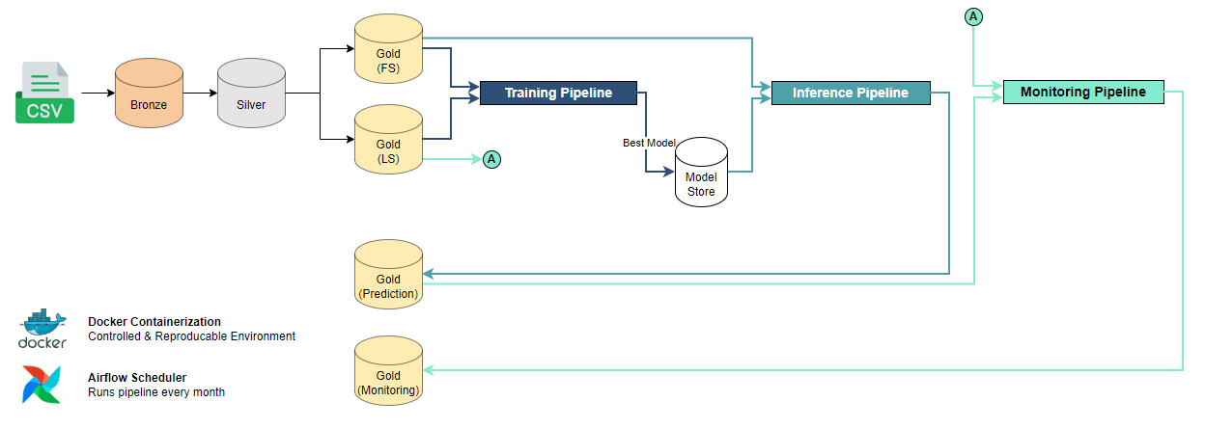
In terms of architectural design, the data will be processed according to the medallion architecture. On a monthly basis, raw data is processed through the bronze and silver layers before splitting to feature and label stores at the gold level. Features and labels from a rolling window will then be used for model training each month and stored in the model store. At deployment date, the best model is selected for deployment.
Starting from the month of deployment, the deployed model is used in conjunction with the latest feature store snapshot to predict the future sales which will be saved to gold tables for the procurement team’s use.
Model monitoring begins one month after deployment when labels materialize (ground truth is available). The monitoring pipeline tracks the model performance through defined metrics as well as the population and characteristic stability of key variables and model output. The entire pipeline is containerized within a docker environment to ensure reproducibility within the production environment. Airflow is used to orchestrate all required tasks each month.

Data Preprocessing
Data processing pipeline consists of two separate streams, standard business and operational level datapoints are processed through the monthly ETL stream while the creation of reference tables for holiday events and store metadata is a one-off process.

Reference Table Processing
The rationale behind the one-off processing for reference tables is due to the need for such data to be unbounded by temporal limitations. It stands to reason that the model should have access to information on what holidays are present in the future (during the prediction snapshot) as these are not data that are generated monthly. To facilitate the engineering of features that encode information regarding holidays that are expected to be happening in the prediction month, there is a need to populate holiday information “ahead of time” – separate from the monthly ETL process. The one-off reference table processing creates bronze and silver layer tables across all time periods to allow gold level processing within the monthly ETL pipeline access to these datapoints for feature engineering.

Monthly Processing Pipeline
The bronze layer serves as a landing zone where raw data in CSV format are ingested. No transformation is done to preserve data lineage for auditing purposes. Monthly partitions are established to align with business planning cycles. Processes include the reading of CSV files from data directory, filtering records within required monthly time window (snapshot_date) and writing them to parquet files with monthly partitioning: YYYY_MM_DD.parquet.
The purpose of the silver layer is to apply data type enforcement while augmenting dataset with columns that are useful for subsequent feature engineering.
Processes include:
- Type casting columns per schema (string, int, float, date, boolean)
- Adding helper columns derived from raw date (year, month, snapshot_date)
- Imputing missing oil prices using monthly averages
- Dropping of records where nulls are present critical columns (date, id)
Typed schemas prevent downstream errors and enable parquet query optimization. The monthly average imputation strategy preserves seasonality patterns and is aligned with the subsequent processing steps to achieve monthly granularity within our feature store.
The purpose of the Gold layer is to create ML-ready features and targets with temporal alignment. Strict adherence (apart from reference tables) to using only features available on month S to predict targets for month S+1 prevents data leakage.
Processes include:
- Engineering 40 total features: 16 holiday features, 22 time-series features, 2 categorical features
- Holiday related features (total count, type breakdown, locale breakdown, national market variants) are created
- Building time-series aggregations (Last Month and Last 3 Months averages/sums for sales, promotions, transactions, oil prices)
- Preserving categorical identifiers (store_nbr, family) for LightGBM's native encoding
- Constructing target variable label_next_month_sales with temporal offset (Features[S] → Labels[S+1])
The feature store pattern decouples feature engineering from model training, enabling feature reuse across experiments. Holiday features capture Ecuador-specific retail patterns (national holidays, regional festivals), while L3M aggregations reduce daily volatility noise and capture seasonal trends. National Market features provide cross-store demand indicators that improve forecasting accuracy for individual store-family combinations.

Model Training
The model training pipeline is set up as a monthly recurring task within the main pipeline that will continue to happen beyond model deployment. A data sufficiency check is performed to ensure that there are enough months available in aligned feature and label stores before model training is triggered.
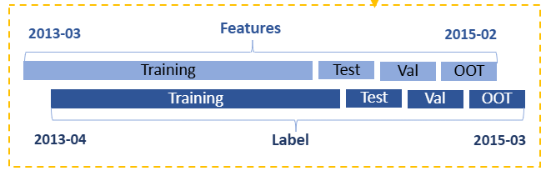
Data split ranges are defined accordingly:
- 18 months training to capture seasonality with sufficient sample size
- 2 months validation for hyperparameter tuning
- 2 months testing for performance results
- 2 months OOT to gauge out of time performance

Model Selection
LightGBM was selected as the core forecasting model due to its superior handling of categorical features, ability to learn shared patterns across entities, and computational efficiency at scale.
- Native handling of categorical features such as store number and product family, which is more efficient than one-hot encoding that would explode 54 stores × 33 families into 87 additional binary columns.
- The global model architecture learns shared patterns across similar stores or product families (e.g., beverage sales trends across coastal stores) while still capturing unique store-specific or product-specific patterns.
- LightGBM handles large datasets efficiently through histogram-based splitting and leaf-wise tree growth, making it ideal for training a global model across 54 stores × 33 product families × 24 months = 42,768 training samples without requiring distributed computing infrastructure.

Evaluation Metrics

R² was selected as the primary metric for model selection because it directly addresses the business need for confidence in forecast reliability. The business team uses model predictions to plan inventory levels, requiring understanding of how much variance in sales the model explains (0-1 scale). This interpretability is more actionable than absolute error metrics for planning purposes. While metrics such as MAE (Mean Absolute Error) provides a more business interpretable value, it also introduces problems due to its sensitivity to scale. As the population distribution of sales falls within a very wide range for different store x family, MAE can therefore be less stable and not truly reflective of the situation for particular store x family combinations. Similarly, as RMSE (Root Mean Square Error) is even more sensitive to scale, it is less effective for evaluating model performance as compared to R² for this use case.

Despite the issues highlighted above, MAE is still included as a secondary metric due to the high business interpretability of average error in sales units. Similarly, RMSE is also included as a secondary metric due to its high error sensitivity. By including RMSE as a metric, prediction errors are more heavily penalized for large deviations, which is critical for reducing stockout/overstock costs

Model Deployment
The deployment date (2015-06-01) as agreed with business stakeholders drives various monthly tasks within the pipeline.

Initial Model Deployment
On the month of deployment, model promotion script is triggered to deploy the best performing candidate model (based on OOT R²) by copying it into the “deployed_model” directory within the model store. From thereon, the deployed model drives inference activities within the pipeline and its training window serves as the reference period in subsequent PSI computations in the monitoring pipeline.

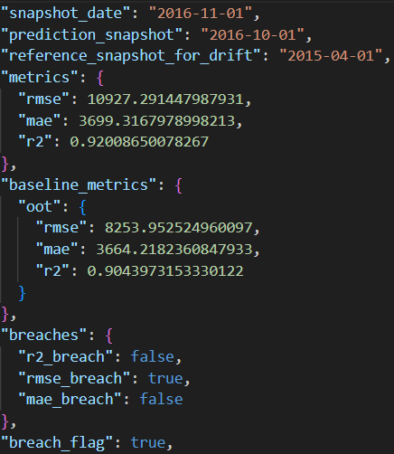
Monthly Redeployment Check
Post deployment month, model promotion script checks the monitoring_report.json file generated by the monitoring pipeline for evidence of performance breaches that will trigger redeployment.
If breaches are detected, the best candidate model is promoted to model store replacing the current production model. If no breaches occur, the current model is retained following a conservative deployment philosophy that prioritizes stability over recency.
Conservative breach thresholds prevent unnecessary model churn from normal statistical variation while ensuring timely intervention when true degradation occurs. More details about breach conditions will be highlighted in Model Monitoring section.

Inference
Starting from deployment month, the inference pipeline is triggered to generate predictions for sales in the following snapshot period. Current snapshot feature store is loaded, and training schema is enforced along with preprocessing transformations that are aligned with what was performed during the initial model training. Predictions are then made for every existing store x family combination and saved in both parquet and CSV formats. The parquet formats will be used in the rest of the pipeline during monitoring while CSV format makes it more convenient for business users to consume. Example output:

Model Monitoring
As agreed with business, model monitoring begins on the month immediately following deployment. This allows the ground truth values to materialize and be available to be used in evaluation. The monitoring pipeline aims to capture information required to assess the suitability and effectiveness of the currently deployed model. This allows for reactive responses such as redeployment to maintain a high level of model performance. The three primary artefacts that are outputs of the monitoring pipeline in each month are the monitoring_report.json, drift_dashboard, as well as the candidate_model_performance_dashboard.

Model Performance
The performance metrics being monitored mirrors the metrics used in model training. The monitoring pipeline evaluates predictions made in the previous month snapshot against ground truth values obtained from current month label store snapshot. In consultation with business stakeholders, these are the agreed performance metrics threshold and the action plan associated with any breaches of each metric.
Priority | Metrics | Threshold | Action if breached
P0 | R² | 0.10 (Absolute drop) | Breach triggers redeployment event next month
P1 | RMSE | 25% (increase from baseline) | 2 consecutive month breach triggers redeployment event next month
P1 | MAE | 25% (increase from baseline)

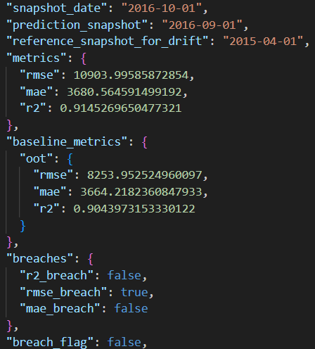
Business alignment was sought with prioritizing R² as the highest priority metric due to its relevance in assessing model’s strength in explaining variances in the target sales number as well as being a more stable scale – invariant indicator. As such, a single month breach of the R² metric will trigger a redeployment event in the next month. While RMSE and MAE are similarly important in assessing model performance, it is expected that their sensitivity to scale will more likely result in slight instability of these metrics. Therefore, a more lenient approach is taken with these two metrics in that a 2 consecutive month breach is required to trigger a redeployment event.
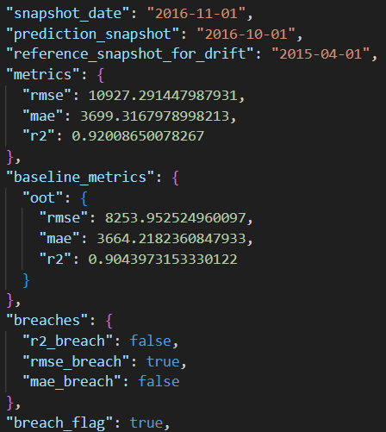
From a design perspective, this is implemented by maintaining separate flag variables indicating the breach of each metric as well as an overall “breach_flag” within the monthly monitoring_report.json.
A breach in R² will immediately set the “breach_flag” to True. Where there are no breaches in R², but breaches in either MAE or RMSE (which are expected to be comparatively more common), the pipeline checks the previous month’s monitoring_report.json for a breach in the same metric before setting “breach_flag” to True.
In each month, the promote_best_model task checks (right after the ETL process) the “breach_flag” indicator in the latest available monitoring_report.json to decide if a redeployment is required.

Candidate Model Performance
While this setup allows for a fully automated model training and redeployment process to ensure reliability of the model prediction. It is important for both Data Science team and business stakeholders to have a continuous view of the performance of the candidate models that are being trained over time. This allows for potential manual intervention if it can be observed that the model performance ceiling has shifted over time due to any concept drift. While the current setup effectively arrests model performance degradation by establishing redeployment rules, it does not allow for business to capitalize on upsides arising from changes in the environment.
As such, the monitoring pipeline tracks and plots the model performance of each candidate model incrementally as they are trained each month, highlighting which model is currently in deployment, allowing decisions to be made on any manual interventions.
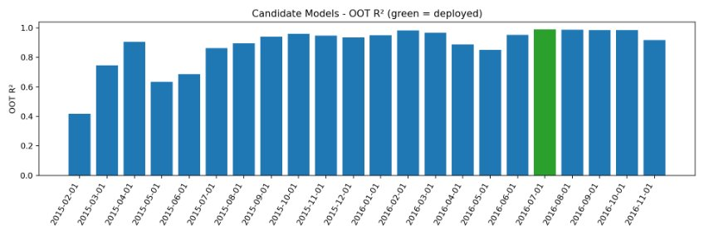

Population and Characteristic Stability
The monitoring pipeline tracks the PSI (Population Stability Index) for identified key variables as well as the CSI (Characteristic Stability Index) for model predictions. The intention is to form a two-layer drift monitoring system where PSI flags any data drift while CSI captures any behavioural drift.
The key variables chosen to be monitored for data drift are selected from the list of feature importance by gain that are extracted from the initial few rounds of model training. These are determined to be the top 10 variables that are most influential in determining the predictions each month and could provide an early signal to any potential model performance degradation. Similarly, CSI provides an early signal to any potential changes in model behaviour as it relies only on predictions rather than ground truth values which arrive on a lagging basis.
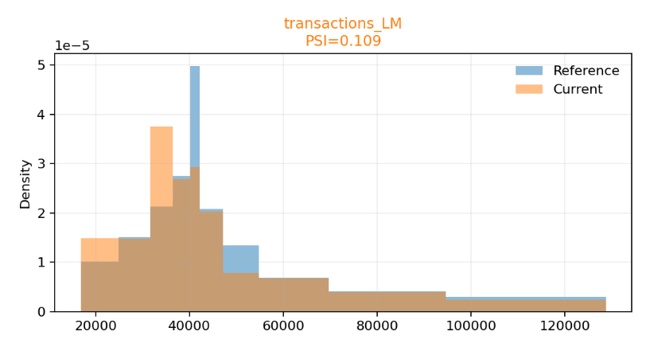
The population distribution of each key variable for the prediction snapshot is overlayed against that of the deployed model’s latest training window snapshot. This allows us to visually observe differences in population distribution beyond having a single numerical representation for each variable. A single dashboard provides a consolidated view of all 10 plots along with the actual PSI value – colour coded to represent their severity level (red for significant drift of more than 25%, orange for moderate drift between 10% to 25%, and green to indicate stable – less than 10% drift. Refer to appendices for sample of full dashboard.

Airflow Orchestration
Lastly, the entire pipeline is orchestrated in Airflow with the following setup.
- DAG 1: store_sales_reference_setup
Scheduled once as one-time initialization to generate static reference tables for holiday events and store-family start dates. It creates lookup tables to eliminate daily joins during feature engineering.
- DAG 2: store_sales_monthly_pipeline
Scheduled monthly and sequential to prevent resource contention. It is a linear pipeline bronze → silver → gold → promote → train → inference → registry → monitor.
Each task is idempotent, enabling safe reruns without data duplication. The linear dependency chain ensures data flows through medallion layers before model training, with inference and monitoring executed only after successful deployment. Total pipeline latency averages 3-4 minutes per monthly run, comfortably within the 24-hour business SLA.

Limitation and Future Considerations
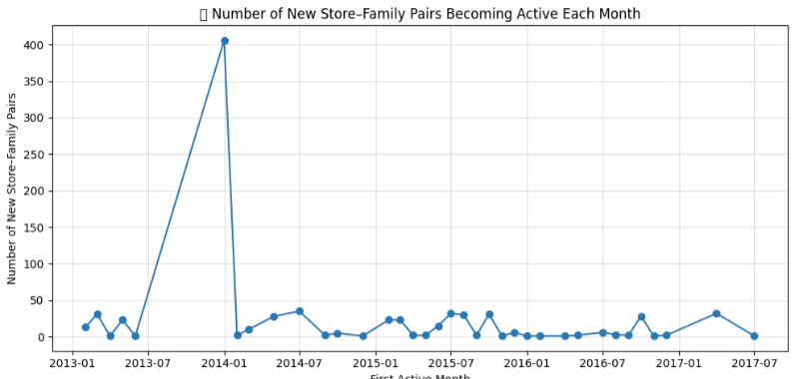
Cold Start Handling – The addition of stores or product family over time introduces new store x family combinations which results in likely no prediction being generated for months where new store family pairs were introduced. It may be possible to incorporate indicators or reference tables which helps the model identify the month where a new product family is being rolled out at a particular store such that predictions could be generated more accurately right from the start.
It can be observed that there are numerous new store x family pairs being introduced during the earlier periods within the dataset which results in slight levels of instability in model performance during the earlier iterations. However, this is partially mitigated with the monthly retraining and automatic redeployment setup that was implemented in our pipeline.
Scalability - The current local file-based architecture limits dataset scalability to single-machine memory (~100GB) and prevents distributed processing for larger store networks or daily-granularity forecasts. Cloud deployment is essential for expanding beyond the 54-store pilot to enterprise-scale retail chains.
Explainability - The current system also lacks prediction-level explainability (stakeholders see forecasts without understanding drivers), risking unexpected behaviour on edge cases. For future deployment, the pipeline shall integrate SHAP values with feature contribution breakdowns (e.g., "20% of this forecast driven by holiday events, 35% by L3M sales trend"), building stakeholder trust in ML decisions.

Conclusion
Overall, this ML pipeline demonstrates production-grade MLOps practices through automated workflows, rigorous data quality controls, and proactive monitoring. The medallion architecture ensures progressive data refinement from raw CSV to ML-ready features, while the 24-month rolling window training strategy balances seasonality capture with recency. Conservative deployment logic—promoting models only on breach conditions—prioritizes operational stability over model recency, preventing churn from statistical noise. Key Achievements:
- End-to-end automation: 55 monthly backfills executing bronze → silver → gold → train → deploy → monitor pipeline
- Robust evaluation: Train/Val/Test/OOT splits with R² > 0.90 performance on out-of-time data
- Proactive monitoring: PSI/CSI drift detection and multi-metric breach thresholds triggering auto-redeployment
- Reproducibility: Dockerized environment, configuration-as-code (YAML), and comprehensive model registry
Business Impact: The system enables inventory managers to trust monthly forecasts for procurement planning (R² > 0.90 explains 90%+ sales variance), reduces manual forecasting effort across 1,782 store-family combinations, and provides transparency through drift dashboards and performance reports.

Appendix:
Drift dashboard
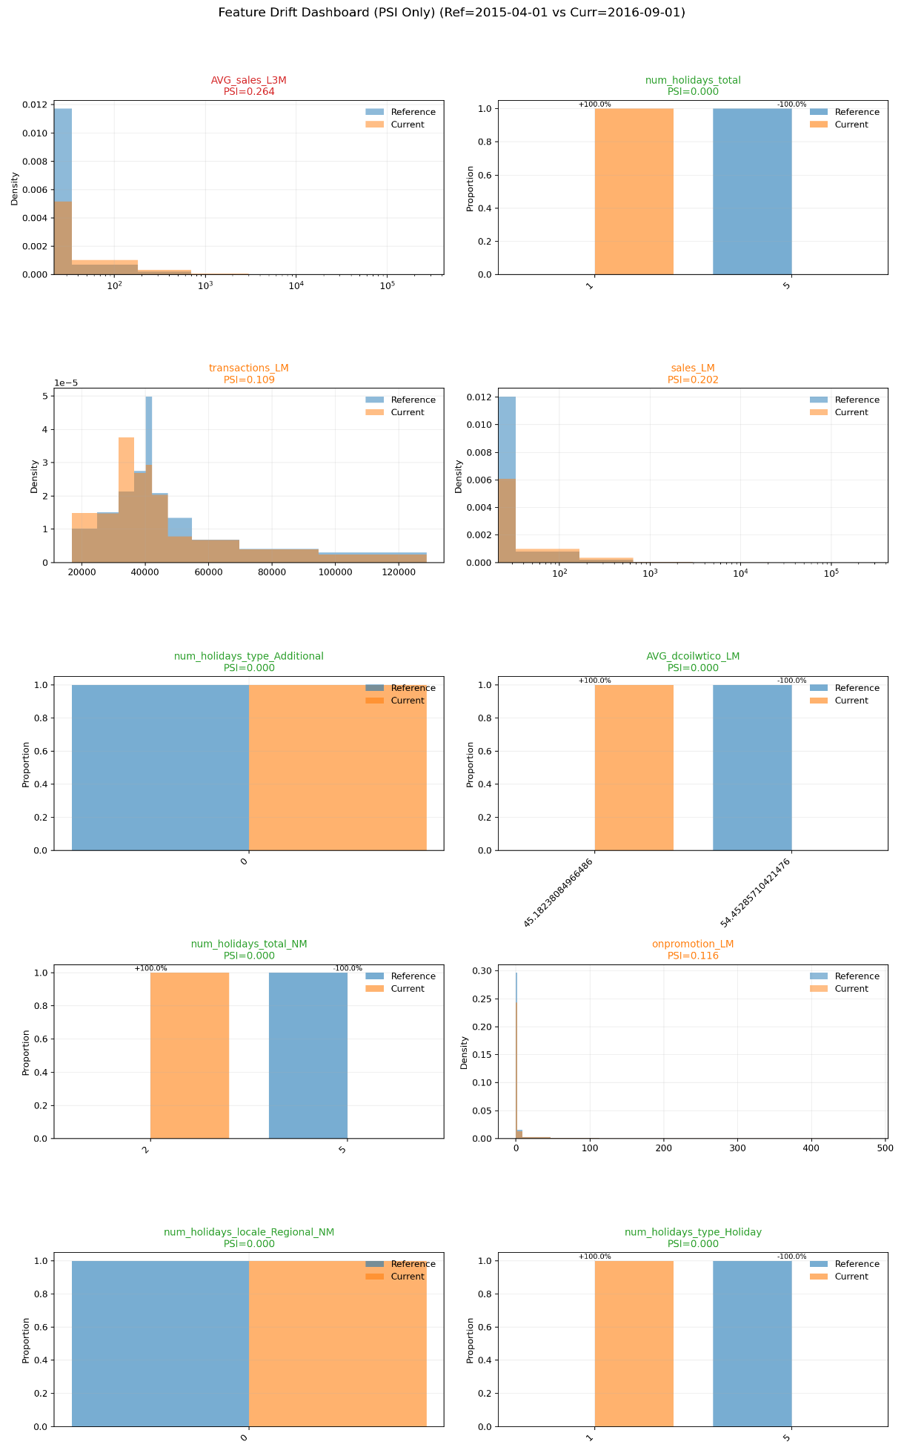
Monitoring Artefacts:
Model Registry:
Monthly Prediction:

